Make-It-All Designs Report
Team Members: Stefan Dupey-Whyte, Imran Jamal, Liam Mordue, Samuel Wade, Simona Lazarova Petseva, Louis James Meredith
Date: 4th November 2018
Executive Summary
The objective of this report is to demonstrate the proposed helpdesk computer system by documenting who the system is aimed at and why, where the influence of the designs came from, the proposed pages/screens of the system along with the screenshots being analysed to allow users to get an early feel of how they would navigate. Then a section explaining which requirements have not been met during this prototype and an explanation of how we play to meet them in the future. Overall the solution should help the stakeholders see how the system will meet their needs and allow for feedback to be received.
The report provides an analysis and evaluation of the current system which Make-It-All are dealing with against the proposed with an explanation of why it is being done. Images are included regarding where our influence came from and justification using the requirements we interpreted from our clients as we believe this will allow the client to have a look at previous solutions which may not be of the same problem but similar and allow them to imagine how this would help them and allow for them to make sure the requirements are spot on. With the design of the different screens this will help with visualisation of the new system and allow for a more in-depth review to be given earlier on and will be easy for it to be compared to the real system and see whether the new system will satisfy the criteria from the client. This will also help the clients of Make-It-All know whether they like the system and allow them to give recommendations before the system gets fully developed.
The report explains in detail how the solution will be helpful to the clients and explains how it will be of an advantage and help efficiency. The major advantages/help to the clients are:
- Unique problem numbers – Help with filtering/sorting problems to reduce ambiguity
- Specialist selection based on algorithm – least busy specialist will be recommended
- Less paper trials – automated system on a database which will be backed up
- Unique logins for each user – will allow multiple accesses and will sync up all input (central information hub)
- Edit logged problem details – can actually change and delete information without looking messy.
The report also investigates the requirements not met in the prototype Some of these include:
- Not having a dedicated section about follow up calls where notes are required about the call
- Not allowing data to be sorted in several manners e.g. sorting based on open and closed queries, sorting based on solution

Table Of Contents
- Purpose and audience
- Design Ideas/Influences
- Designs Of The Different Screens
- How The System Will Make Life Easier For The Stakeholders?
- Suggested Implementations For Further Versions Based On Requirements
- Bibliography

- Purpose and Audience
The purpose of the website is to enable the stakeholders of the current manual helpdesk which the client calls ‘unsatisfactory’ due to it being very difficult to track how the problem is dealt with. There is also the problem that usage of the helpdesk is expanding so Make-It-All will be employing ‘two, or maybe more operators in the future and the manual system cannot cope with this’. Our solution will enable the tracking of problems to be done as its status will be updated on the system for everyone to see and with unique logins each operator will be able to be on the system at the same time and it will synchronise information, there will be no redundancy, and it will overall be a more efficient operation. The system will be aimed mainly at the helpdesk operators, analysts and the specialists to be able to track whether they are resourced to solve problems in an acceptable time, and whether there are subject areas where training should be given to employees. This will also have a positive impact on the reporters of calls who phone in and it should help the process be a lot smoother if they want information on the status of their problem. From this we aim to help Make-It-All run a lot more efficiently.
- Design Ideas/Influences
The team’s idea has come from the influence of a ticketing website as we believe this is an efficient way to be able to keep track of problems which need to be solved. An example of this is the status of each query, which will allow all the operators and specialist to know the stage of each job and how they should be progressing along with them. So, the possible statuses that will be available are ‘open’ or ‘closed’. Along with the status, there will be the ID number given to each problem to uniquely identify each one and filer the number of problems currently being viewed. The query type will be shown and next to it the sub problem will be shown. The main problem will be used as a filter for specialists, so they only see jobs which could be assigned to them or are associated to them. Instead of the username it will also have the full name of the reporter of the problem, so they can be found within the company and/or their communication details can be obtained. The next section will include reasons for the call as well as notes, which will be editable to allow for the helpdesk operator to add more detail and to help the specialist understand the problem properly and give a solution. One of the last columns will have the time the job has been live for, so the specialist can see how they are progressing. The final section will include the date and time which the problem was resolved, and this will also update the status to completed.
Specialists will also be able to have their own specialised view where they can see jobs assigned to them by the operator. This can be done by filtering using their name, which can be sorted in many ways such as alphabetic order. It will enable them to see how many jobs are allocated to them or other people within their specialist group. Overall the layout will be inspired by the screenshot below especially the query page, as this is the main page with some altercations which are highlighted around the diagram. We felt that this layout would be easy to adapt to, and the information on each query is displayed conveniently. The colour scheme will be red as it will help key information stand out on white backgrounds as red is seen a warning/caution, so people will make sure to notice it and its good in testing environments. (Patel, 2018)
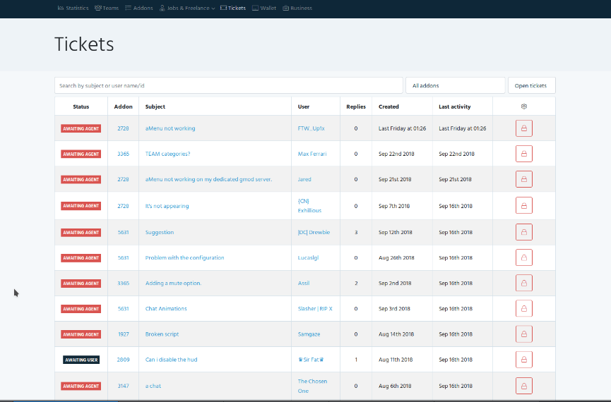
The status lets users known if been assigned to an agent or not
Unique number
Subject of the conversation
The left column includes the user who started the subject and the right includes the number of replies
This section includes when the post was created so let’s people know how long it’s been live
Will include the last time it was updated
Will include date and time of when the problem was resolved
Will allow user to search system according to particular parameters in order to filter down results.

The above screenshot is what was used as the main influence to log the queries/problems coming in as we was inspired by the ticket system and developed our own one with a variation according to this one in order to make it easier for the operators/specialist to adapt and we also believe our design is more user friendly as not as much is clustered on the screen and it is also very easy to navigate around with a consistent theme maintained throughout.
- Designs of the different screens
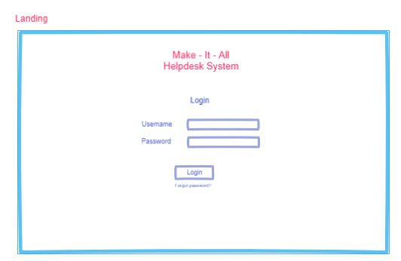
Login page where operators and specialist can log in and gain access to the system with their username ad password
Figure 2 - Login Page

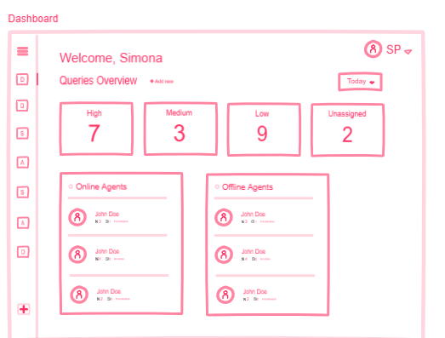
This shows the priority of the queries/problems along with the amount not assigned
Can filter according to time frame
Shows which agents are available and are not in case a high priority call comes through, so it can be assigned to someone active
Menu bar to get to different tasks/sections
Figure 3 - Dashboard/Welcome Page Once Logged In

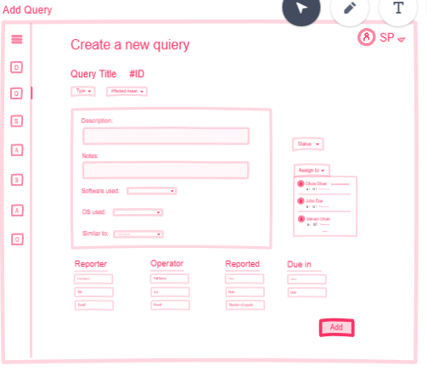
Allows for a new problem to be reported/logged
Dropdown menu for problem type along with affect asset.
Allows for description and notes to be recorded about problem. Along with software, OS affected
Allows for status to be updated and dependant on problem type will show available specialists in order of the one with the least work load first
Includes information about the reporter (person calling), operator call came too, details about when the problem was reported and when its due in by.
Figure 4 - Create/Report A New Problem Page

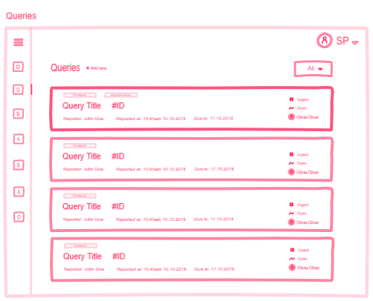
Once again allows all queries to be filtered
Allows priority, status, name of specialist assigned to the problem, reporter, time of the incident being reported, when its due be and the problem type to be displayed so that specialist/operators can view all the jobs, edit them or search for previous solutions.
Figure 5 - Query List Page

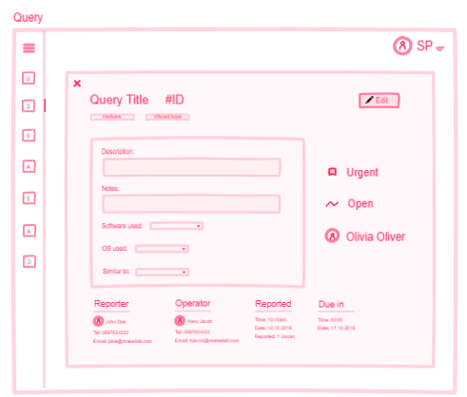
This is what the users will see when they click into an already open job which they want to edit, all the information will be filled in which previously wasn’t and the user will be able to change what they need to accordingly
Figure 6 - Edit Problem/Query Page

- How Will This Make Life Easier For The Stakeholders?
The current problem is described as ‘The current helpdesk operator logs the call in a records book and allocates one of a number of specialists to deal with the problem. This manual logging system is unsatisfactory as it means it is very difficult to track how the problem is dealt with.’ Therefore, the new proposed solution should help make this easier as each call will be assigned a unique number. This then implies that all the user has to do is select the problem type from the information they have been given and then provide notes and a description. The system will then select a specialist based on the problem type and the amount of jobs they have in their queue to make sure they all get evenly distributed as currently this is not the case. The operator will also be able to see which agents are active and how many jobs they have in their queue in case they need to manually select
This should also prevent paper trails getting lost as an online database should provide a backup of all calls and data which is more efficient and mitigates data redundancy. In the case of multiple helpdesk operators in the future, the new system will help sort out jobs and keep track of ones that have already been logged and will allow all operators to have access to these along with specialist. This will also allow calls to be logged and received at the same time making the process more efficient and accessible for the operators. It will also help with the timing of jobs as it will be easy to see how long the job has been live for, so the specialist can see whether they are working towards their deadline as when the problem is logged the time and date is and the operator will have more information to give regarding follow up calls to the person experiencing the problem. On the topic of follow up calls, using the filter feature would be more advantageous as the paper system would not be sorted in any particular manner so it could take a long time to find a previous call from a customer. With the ability of being able to filter and sort jobs according to problem types, this could become a very useful feature for specialists if they have dealt with similar jobs previously. They can use the information from the previous jobs to help solve new ones and can simply type in caller names to bring up details regarding previous problems or create new ones.
One of the requirements was that the ‘system must allow problems and comments to be edited’ which on a manual paper system is not possible however on a digital system it is, so this will once again be advantageous to the company.
- Suggested Implementations For Further Versions Based On Requirements
A suggested implementation that will be made in the next iteration is the change of the colour from red to blue as it is seen as a more popular colour and is described as a ‘calm professional colour (Morin, 2014)’. On the other hand, red is seen to ‘reduce analytical thinking’ which will be less beneficial to the end user. Another implementation is creating a dedicated section for follow up calls, where notes are required about the call. Currently in the solutions state, it only allows for problems to be created or edited and there is no specific section for follow up calls. This could be implemented by adding a button for the user to look at open jobs and select follow up calls, where they will be prompted to include details on the call.
The final functionality implementation is to allow data to be sorted based on several factors e.g. sorting based on open and closed queries, as currently it is limited to certain factors such as names which may be insufficient for particular queries where all information is not remembered.
- Bibliography
Morin, A. (2014, February 4). How To Use Color Psychology To Give Your Business An Edge. Retrieved from Forbes: https://www.forbes.com/sites/amymorin/2014/02/04/how-to-use-color-psychology-to-give-your-business-an-edge/#3e04cc56170a
Patel, N. (2018, November 4). Psychology of Color. Retrieved from neilpatel: https://neilpatel.com/blog/psychology-of-color-and-conversions/

